# Sustainable Smart City Assistant Using IBM Granite

# LLM

# *Generative AI with IBM*

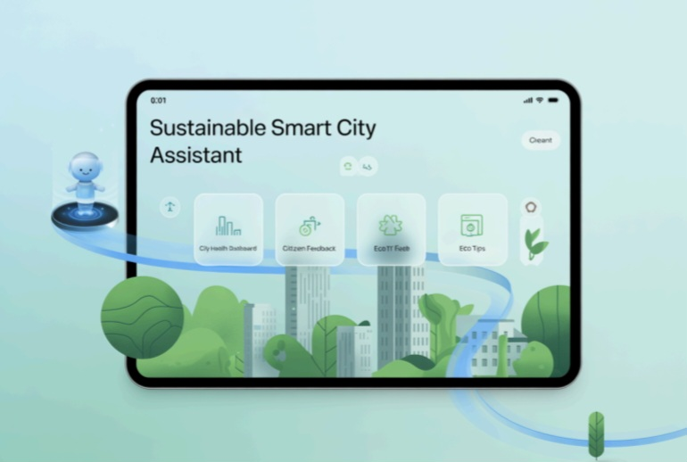

## Project Description:

*Sustainable Smart City Assistant uses the Granite model from Hugging Face to help With city sustainability, governance, and citizen engagement. It includes quick tools for a City Health Dashboard, citizen feedback, document summaries and eco tips. This Project will be deployed in Google Colab using Granite for easy setup and smooth Performance.*

## Pre-requisites:

1. *Gradio Framework Knowledge: Gradio Documentation*
2. *IBM Granite Models (Hugging Face): IBM Granite models*
3. *Python Programming Proficiency: Python Documentation*
4. *Version Control with Git: Git Documentation*
5. *Google Collab’s T4 GPU Knowledge: Google collab*

## Project Workflow:

*Activity-1: Exploring Naan Mudhalavan Smart Interz Portal.*

*Activity-2: Choosing a IBM Granite Model From Hugging Face.*

*Activity-3: Running Application In Google Colab.*

*Activity-4: Upload your Project in Github.*

1.Choose a IBM Granite model From Hugging Face.

*● Search for “Hugging face” in any browser.*

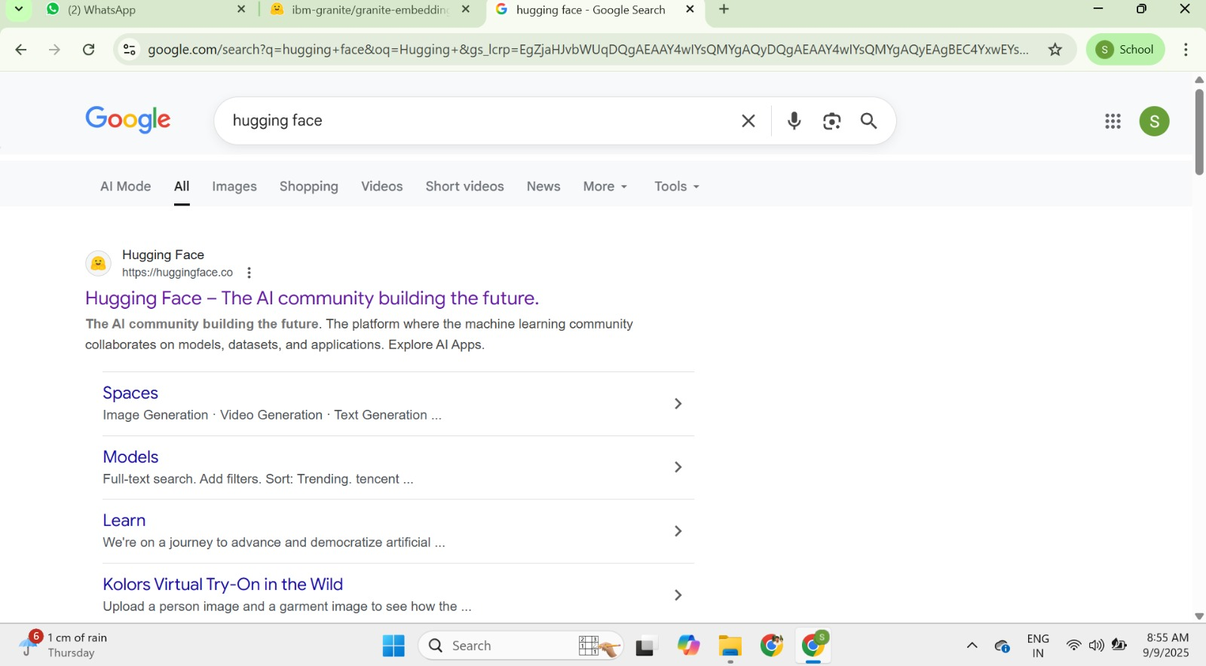

*● Then click on the first link (Hugging Face), then click on signup and create Your own account in Hugging Face. Then search for “IBM-Granite models” And choose any model.*

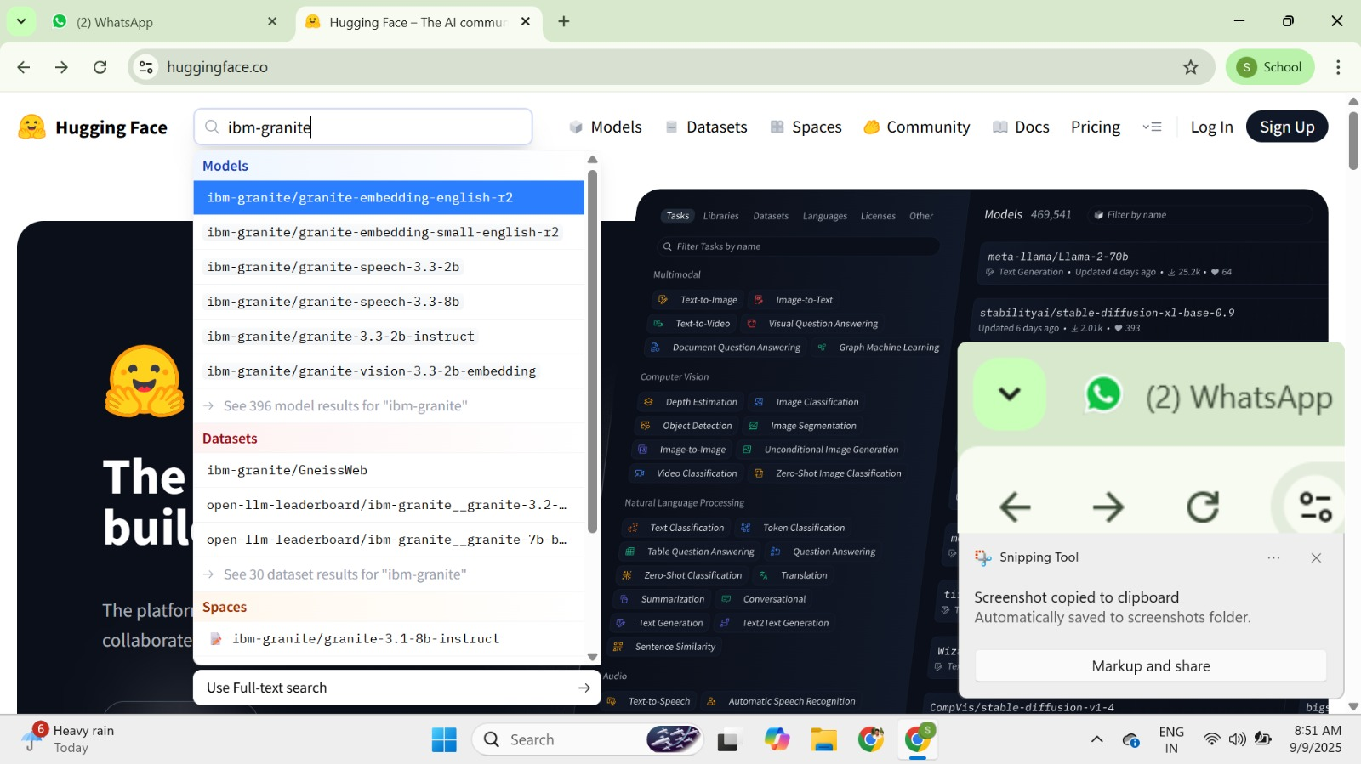

*● Here for this project we are using “granite-3.2-2b-instruct” which is Compatible fast and light weight.*

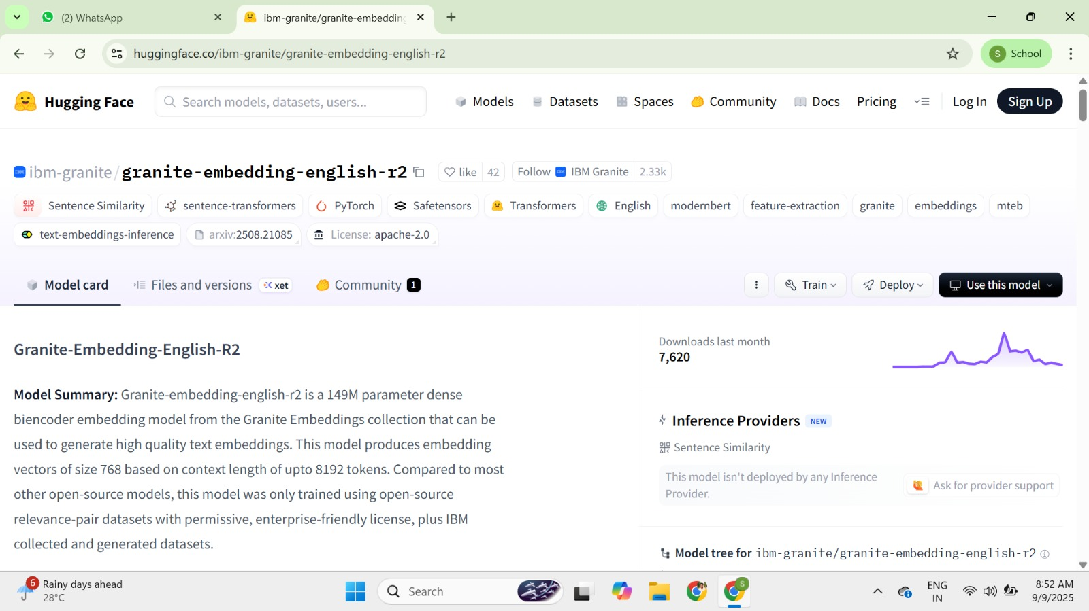

*● Change the title of the notebook “Untitled” to “Health AI”. Then click on “Runtime”, then go to “Change Runtime Type”.*

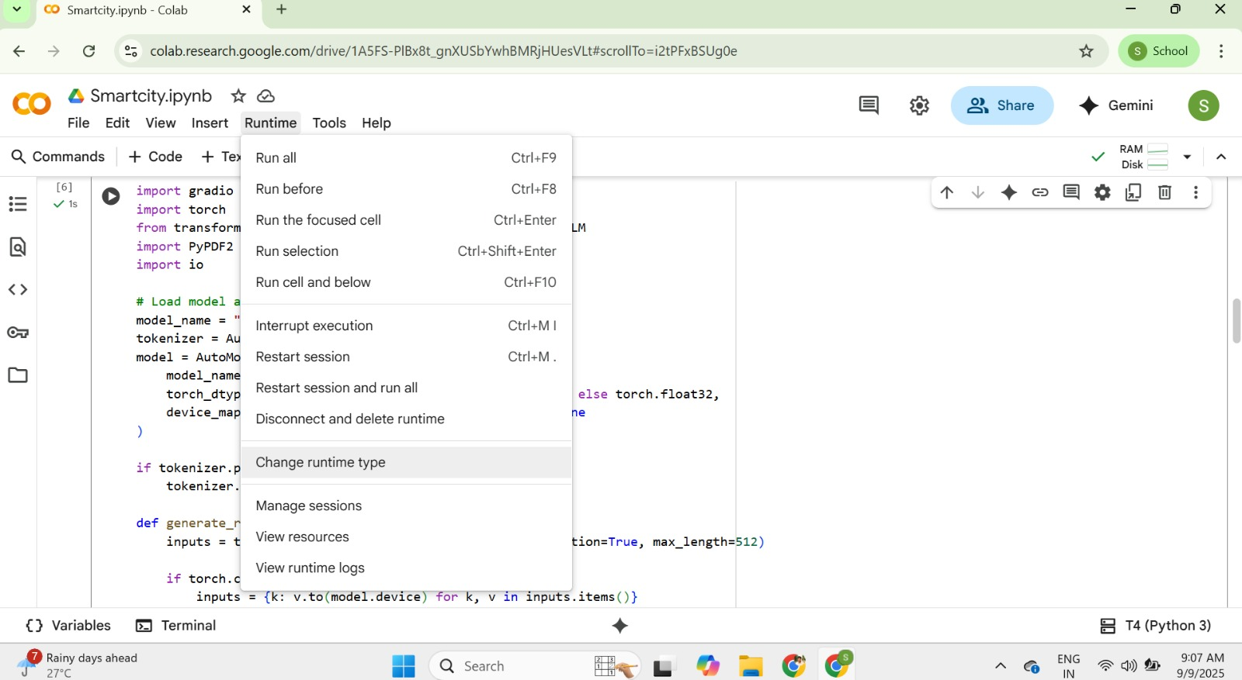

*● Choose “T4 GPU” and click on “Save”*

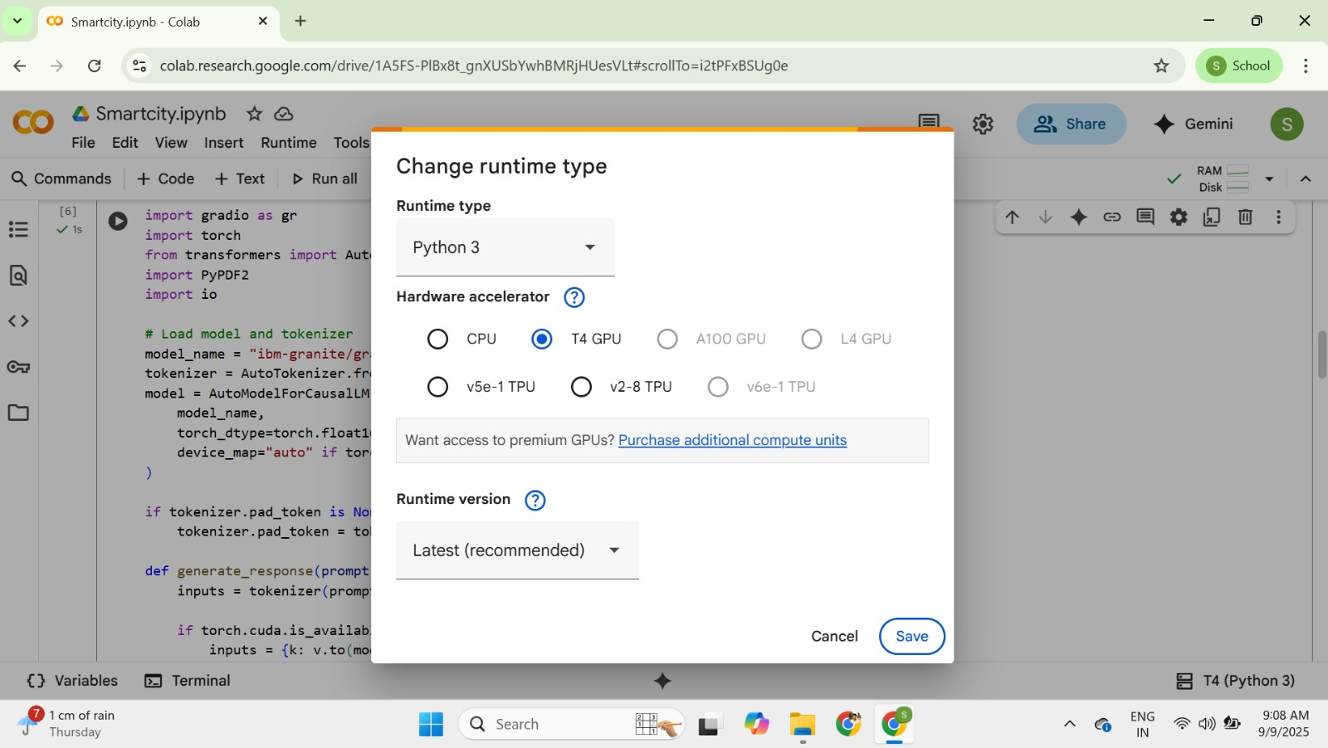

*● Then run this command in the first cell “!pip install transformers torch Gradio PyPDF2 -q”. To install the required libraries to run our application.*

**

*● Then run the rest of the code in the next cell.*

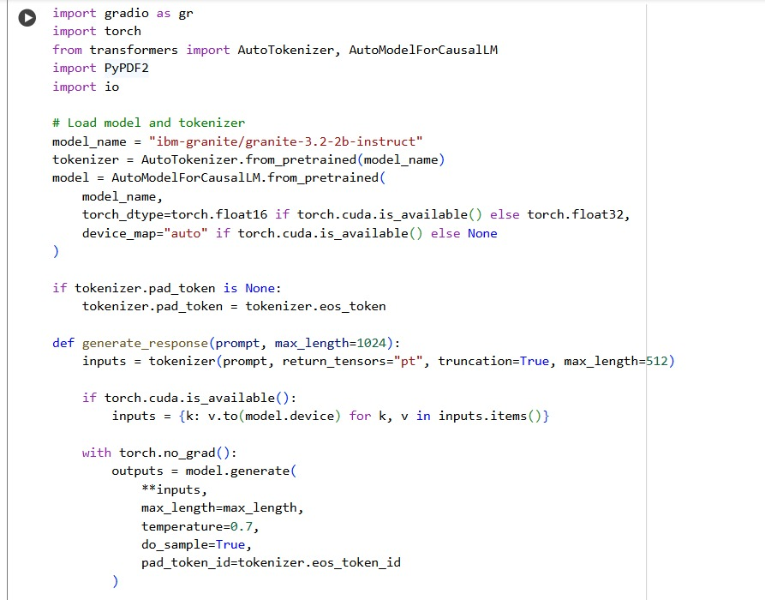

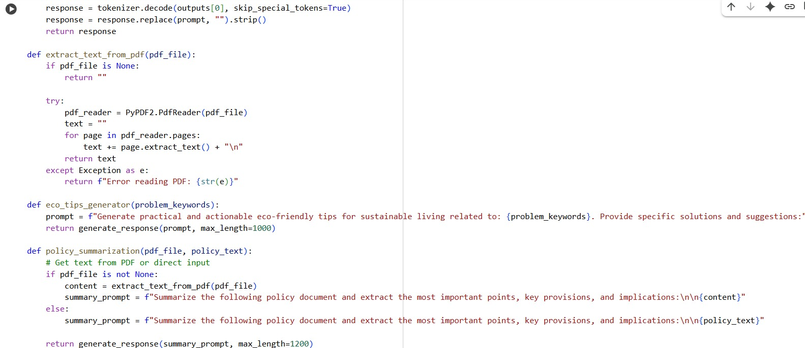

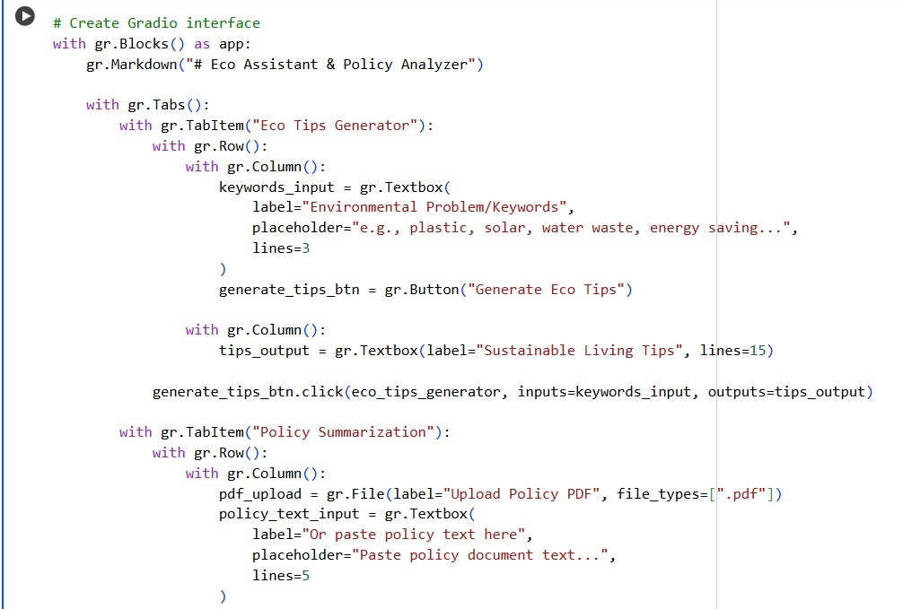

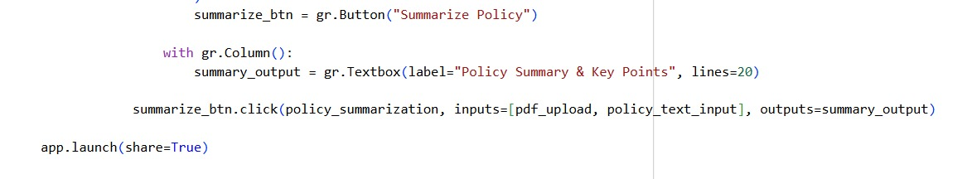

*● You can find the code here in this link: Sustainable Smart City Assistant*

***OUTPUT:***

*● Now you can see our model is being Downloaded and application is Running*

*● Click on the URl to open the Gradio Application click on the link*

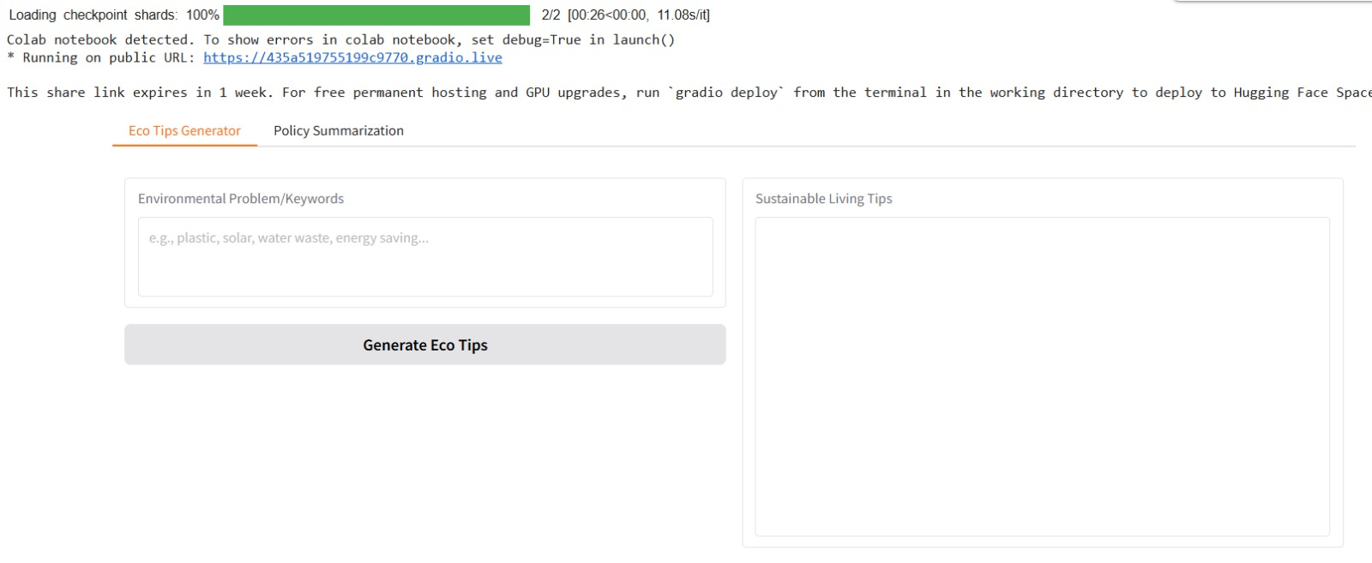

*● You can View the Application is the running in the other tab*